I was getting this error while trying to write file through spark:  
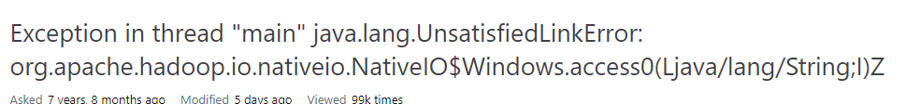

For this we need to download the Hadoop.dll file and put it with winutils in Hadoop folder:  
<https://github.com/steveloughran/winutils/tree/master/hadoop-3.0.0/bin>